**PART D**

library(deSolve)

#i = initial values of state variables

i<-c(x=0,y=0,z=0)

#times = time sequence for output

time<-seq(0,10,by=1)

#function that computes values of derivatives in the system

togglefunc<-function(time,state,pars){

x<-state[1]

y<-state[2]

z<-state[3]

#x<-(ax+bx*S)/(1+S+(z/zx)^nzx)

#y<-(ay+by*S)/(1+S+(x/xy)^nxy)/dely

#z<-1/(1+(x/xz)^nxz+(y/yz)^nyz)/delz

dxdt=(ax+bx*S)/(1+S+(z/zx)^nzx)-x

dydt=(ay+by*S)/(1+S+(x/xy)^nxy)-dely*y

dzdt=1/(1+(x/xz)^nxz+(y/yz)^nyz)-delz*z

return(list(c(dxdt,dydt,dzdt)))

}

#set parameters

pars<-c( S<-0.02,

ax<-3.9*10^-2,

ay<-4.3*10^-3,

bx<-6.1,

by<-5.7,

dely<-1.05,

delz<-1.04,

zx<-1.3*10^-5,

yz<-11*10^-3,

xz<-12*10^-2,

xy<-7.9*10^-4,

nzx<-2.32,

nxy<-2,

nxz<-2,

nyz<-2)

#run solver

out<-ode(i,time,togglefunc)

#plot(out)

#plot

#plot(x=out[1:11],y=out[12:22],xlab='time',ylab='X when S=0.02')

#plot(x=out[1:11],y=out[23:33],xlab='time',ylab='X when S=10')

plot(x=out[1:11],y=out[34:44],xlab='time',ylab='X when S=10^5')

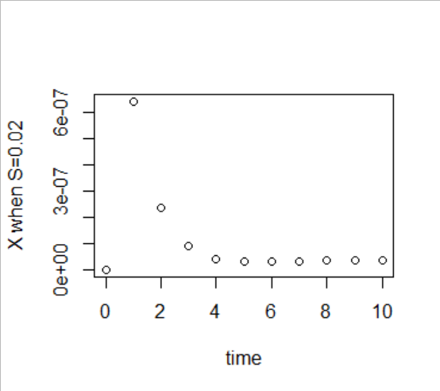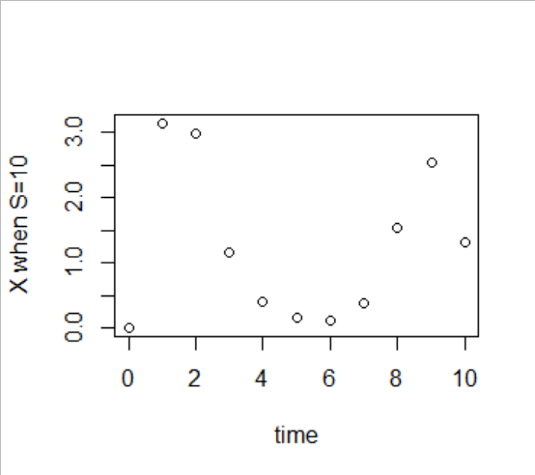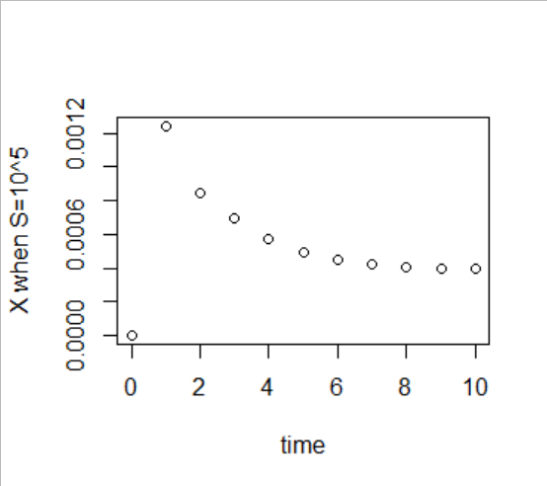

**PART C**

library(deSolve)

#i = initial values of state variables

i<-c(x=100,z=100)

#times = time sequence for output

time<-seq(0,10,by=1)

#function that computes values of derivatives in the system

togglefunc<-function(time,state,pars){

x<-state[1]

z<-state[2]

dzdt=1/(1+(x/xz)^nxz)-z

dxdt=(ax+bx*S)/(1+S+(z/zx)^nzx)-x

return(list(c(dzdt,dxdt)))

}

#set parameters

pars<-c( ax<-1.5,

bx<-5,

zx<-0.4,

xz<-1.5,

nzx<-2.7,

nxz<-2.7,

S<-0)

#run solver

out<-ode(i,time,togglefunc)

#plot

plot(x=out[0:7],y=out[12:18],main='X when S=0')

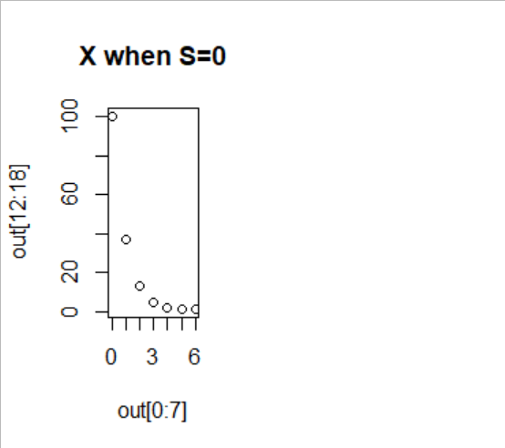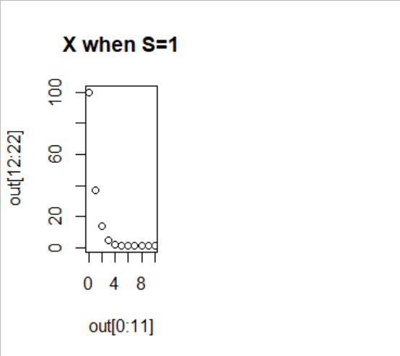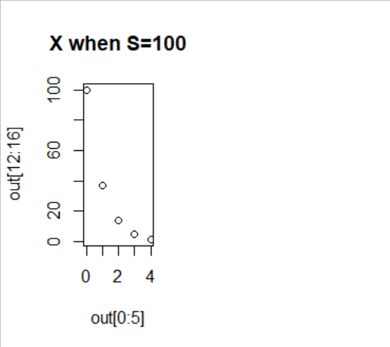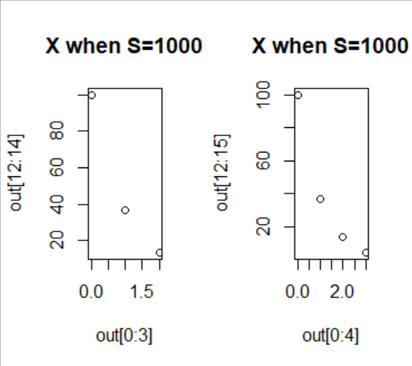

**PART E**

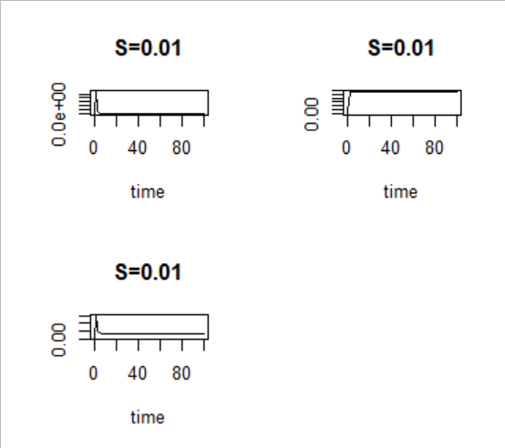



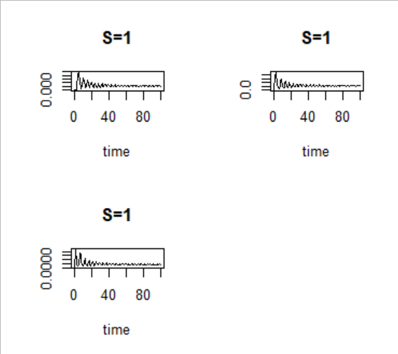



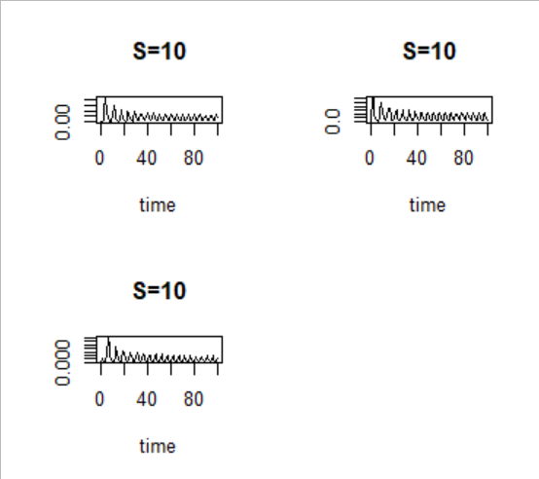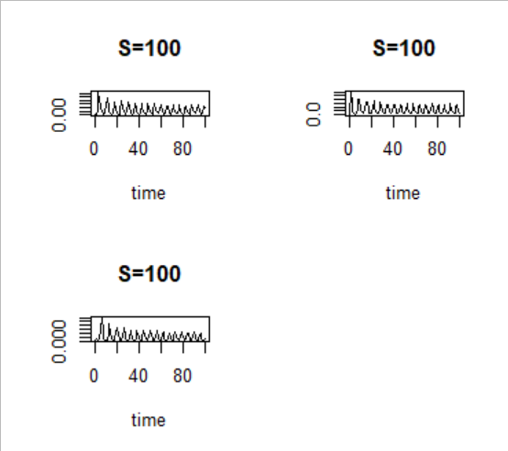



**PART F**

